**Assignment: 01**

**Question: 01**

**function insertion (Array A)**

**i ← 1**

**while i < length(A)**

**j ← i**

**while j > 0 and A[j-1] > A[j]**

**swap A[j] and A[j-1]**

**j ← j - 1**

**end while**

**i ← i + 1**

**end while**

**end function**

**Code:**

**Main.java:**

public class main {

public static void main(String args[]) {

int arr[] = { 34, 67, 5, 12, 6, 72, 1, 29 };

InsertionSort is = new InsertionSort();

is.sort(arr);

is.printArray(arr);

}

}

**InsertionSort.java:**

public class InsertionSort {

public void sort(int arr[]) {

int n = arr.length;

int i = 1;

while (i < n) {

int key = arr[i];

int j = i - 1;

while (j >= 0 && arr[j] > key) {

arr[j + 1] = arr[j];

j = j - 1;

}

arr[j + 1] = key;

i++;

}

}

void printArray(int arr[]) {

int n = arr.length;

for (int i = 0; i < n; ++i)

System.out.print(arr[i] + " ");

System.out.println();

}

}

**Code Screen Shot:**

**main.java**

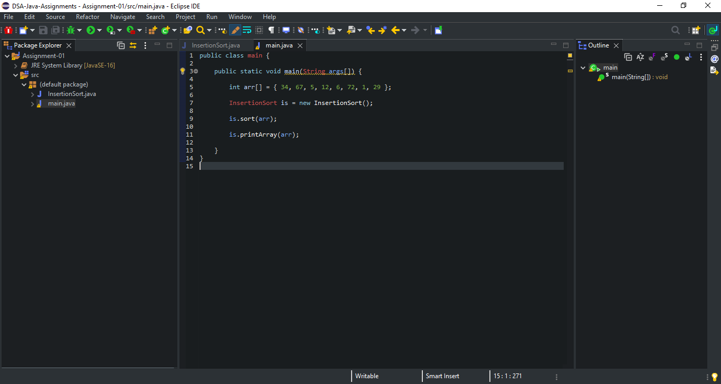

**InsertionSort.java:**

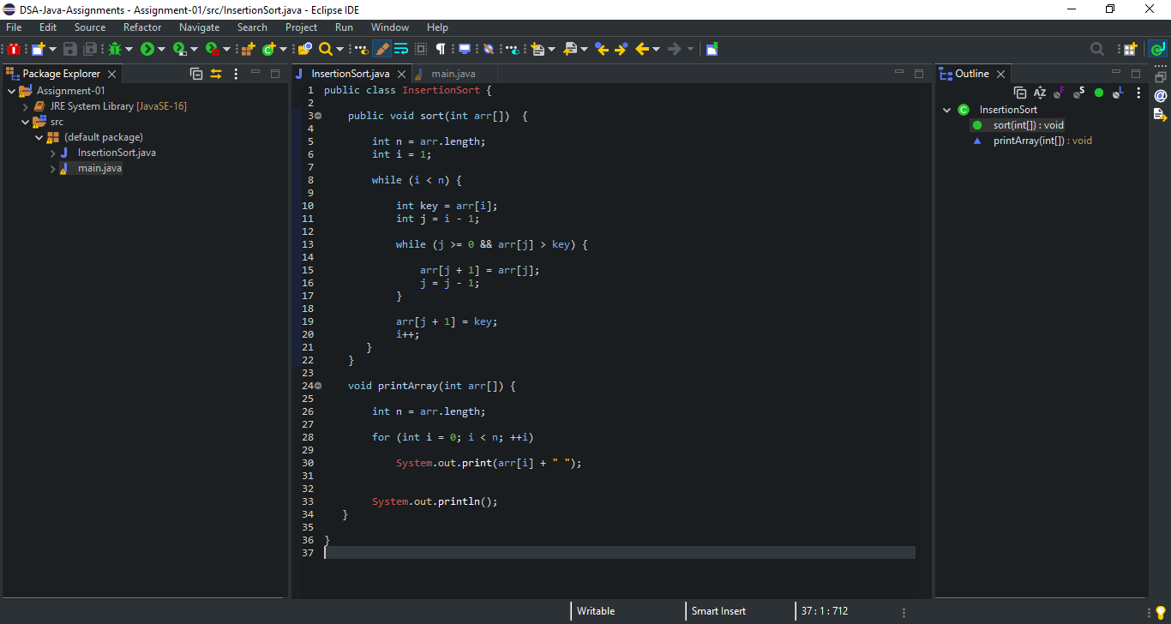

**Code Output Screen Shot:**

